Experiment – 12
Approval Process
Creating an Approval Process in Zoho Creator
Department of Computer Science and Engineering
Student Name: Sajine Santhakumar
Roll No: 240701459
Application Name: Parking Slot Reservation (Purchase Request / Procurement Application)

Objective
To create an approval process in Zoho Creator that sends every new Purchase Request record to an approver for review, and to define the actions that run when the approver approves or rejects the record.

Introduction
An approval process in Zoho Creator is a workflow in which a record must be reviewed by one or more approvers before it is accepted. When a record is added to the chosen form, it is sent to the approver, who can approve or reject it. Actions can be attached to the start of the process and to each outcome, such as sending an email, updating fields of the record, adding records to another form, or running a Deluge script. The approval process therefore moves a record forward according to the decision of the approver, with no manual follow-up.

Approval Process Components
Table 12.1: Components of a Zoho Creator approval process.
Component | Description | In this Experiment
Form | The form whose new records need approval | Purchase Request
Approver | The person or role who reviews the record at a level | Level 1 Approver: tony441007
Approval and Denial labels | Names of the two decision buttons shown to the approver | Approve and Reject
Actions on start | Actions that run when the process begins | None added
Actions on approval or rejection | Actions that run after the decision of the approver | Send email to the submitter, and update the record on approval
Table 12.2: Settings used to create the approval process.
Setting | Value
Workflow name | HOD Approval
Form | Purchase Request
Run this process | Always
Approver type | User
Approver | tony441007
Approval label | Approve
Denial label | Reject
Table 12.3: Fields updated when the HOD approves a record.
Form | Criteria | Field | New Value
Purchase Request | Current record | Approval Status | Pending Finance Approval
Purchase Request | Current record | Hod_Decision | Approve

Screenshot-based lab record
The following pages contain the actual Zoho Creator screenshots of the approval process configuration.

Screenshots 1 – Approvals Tab
The Approvals tab of the Workflow section is empty and explains that it runs actions at different steps in the approval process of a record. A new process is started with Create Workflow.
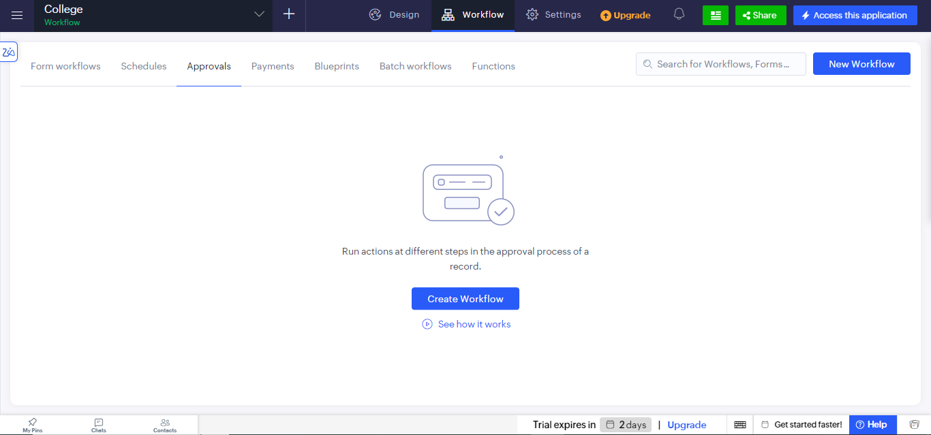
Figure 1: Approvals tab of the Workflow section before an approval process is created.

Screenshots 2 – Creating the Approval Process
The Run approval process on record addition page asks for the form, the name of the workflow, and when the process should run. The Purchase Request form was chosen, the workflow was named HOD Approval, and the process was set to run Always, that is, for every new record, rather than only on a condition.
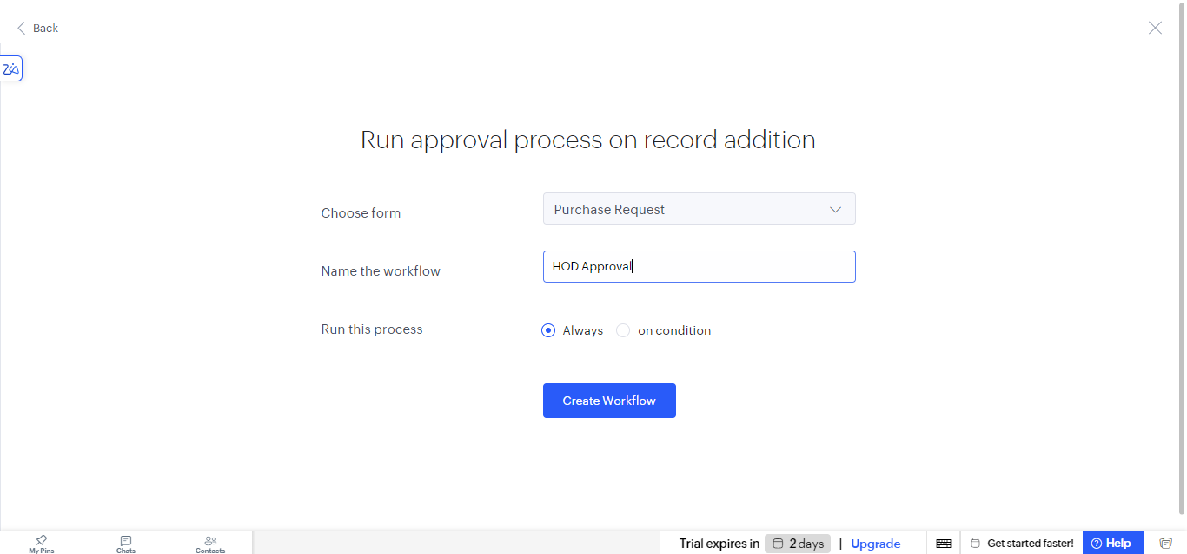
Figure 2: Run approval process on record addition page for the Purchase Request form.

Screenshots 3 – Adding the Approver
The process page asks for an approver to review the records added in the form Purchase_Request. In the Add New Approver panel, the type was set to User, the user tony441007 was selected as the approver, and the labels Approve and Reject were given for the approval and denial buttons. Save Approver stores the approver.
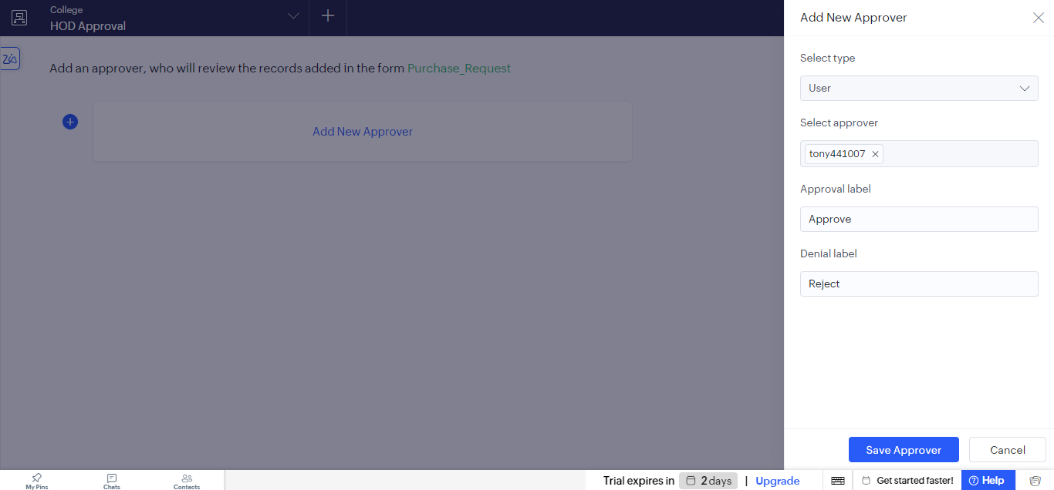
Figure 3: Add New Approver panel with the approver and the approval and denial labels.

Screenshots 4 – Approval Events and Actions
The process page now shows the approval events. Actions to execute on start can be added at the top, and Level 1 Approver tony441007 has two outcomes, Approve and Reject. Under Approve, an action that sends an email to the submitter of the record runs without any condition, and further actions can be added with Add New Action. The Approval Events list on the right shows On Start and Level 1 Approver with Approve and Reject.
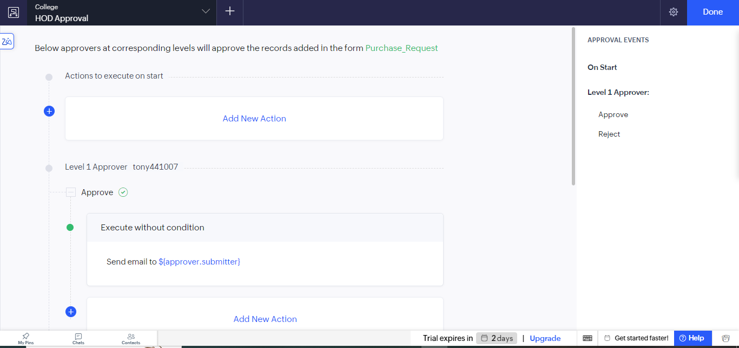
Figure 4: Approval events with the Level 1 Approver and the actions under Approve.
Add New Action offers the options to run the action Always or on a condition, and four action types: Notification, Data access, Integrations, and Deluge script.
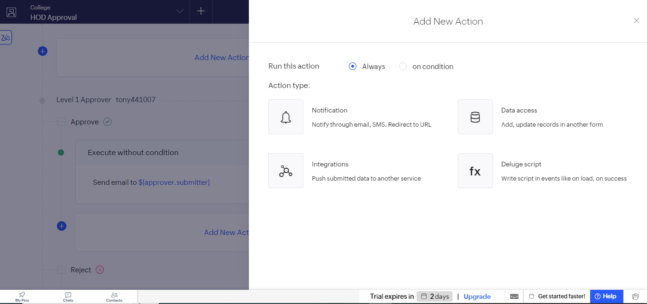
Figure 5: Add New Action panel showing the available action types.

Screenshots 5 – Update Record Action
A Data access action was used to update the Purchase Request record when the approver approves. The criteria were set to the Current record, and two fields were updated: Approval Status was set to Pending Finance Approval, and Hod_Decision was set to Approve. The record thus moves on to the Finance stage once the HOD has approved it.
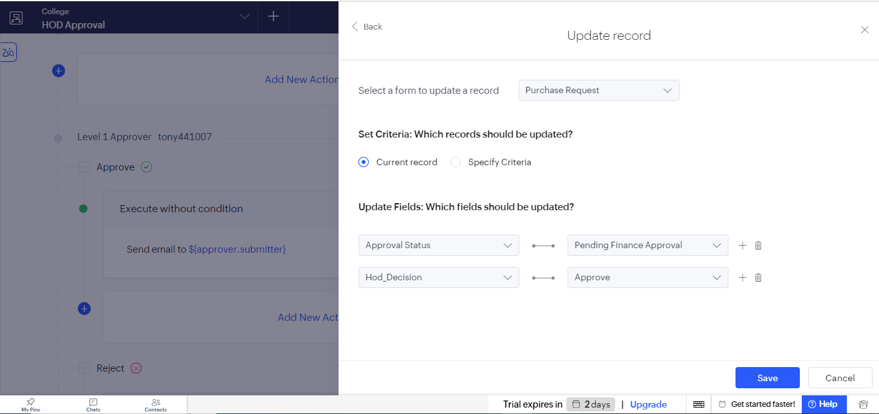
Figure 6: Update record action that sets Approval Status and Hod_Decision on approval.

Observation
The approval process was created without writing any code. Every new Purchase Request is sent to the HOD, who sees the Approve and Reject buttons, and each decision can start its own actions. On approval, the submitter is informed by email and the record is updated automatically so that its status shows that it is now waiting for Finance. The same process can be extended by adding more levels of approvers, so that a request passes through several reviewers one after another.
An approval process differs from a blueprint, which controls the stages a record must follow by means of transitions chosen by the user, and from a form workflow, which only reacts to an event. In an approval process the record waits for the decision of a named approver, and the outcome of that decision decides what happens next.

Result
An approval process named HOD Approval was successfully created for the Purchase Request form. The user tony441007 is the Level 1 approver with the Approve and Reject outcomes. On approval, an email is sent to the submitter and the record is updated with the status Pending Finance Approval and the HOD decision Approve.

